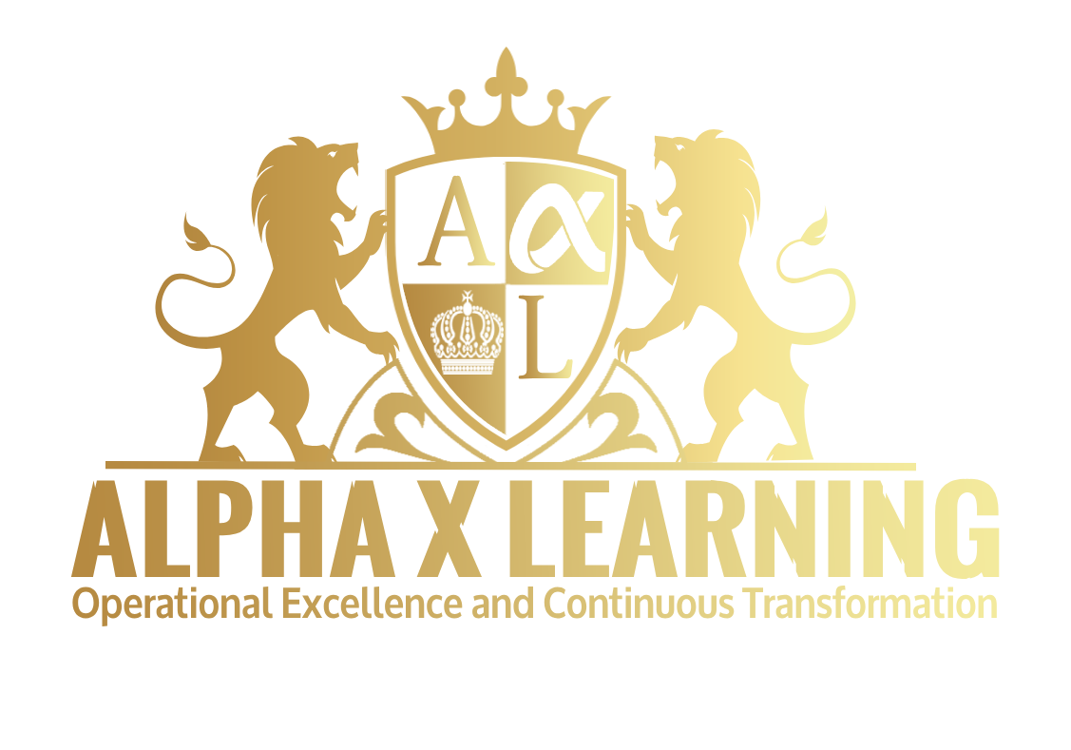
QUALITY, COMPLIANCE &
STANDARDS
Website Course Content Portfolio
Standardized Website-Ready Content • 3 Programs • Duration Omitted
alphaxlearning.com

Portfolio Structure
• Internal Auditing & Compliance Management Audit & Compliance
• Quality Management Systems – ISO 9001:2015 Core Quality Management
• Quality Tools, Root Cause Analysis & Continuous Improvement

Internal Auditing & Compliance Management Audit & Compliance
Why Attend

Learning Objectives
By the end of this course, participants will be able to:
• Explain the principles and purpose of internal auditing
• Develop risk-based audit programs
• Prepare audit plans and checklists
• Gather and evaluate objective evidence
• Conduct effective audit interviews
• Identify and document audit findings
• Evaluate compliance and control effectiveness
• Perform root cause analysis
• Develop corrective action requirements
• Prepare professional audit reports
• Conduct audit follow-up and verification
• Improve organizational compliance through internal auditing

Target Competencies
• Internal auditing
• Compliance assessment
• Risk-based auditing
• Audit planning
• Evidence gathering
• Audit interviewing
• Nonconformity identification
• Root cause analysis
• Corrective action
• Audit reporting

Course Outline

Fundamentals of Internal Auditing
• Purpose and value of internal audits
• Internal audit principles
• Audit terminology
• Audit types
• First-, second-, and third-party audits
• Compliance versus performance auditing
• Risk-based auditing
• Auditor responsibilities and ethics

Audit Planning
• Developing an audit program
• Establishing audit objectives and scope
• Risk-based audit planning
• Determining audit criteria
• Selecting audit teams
• Preparing audit schedules
• Developing audit plans
• Preparing audit checklists
• Document review before the audit

Conducting the Internal Audit
• Opening meetings
• Audit communication
• Interviewing techniques
• Process observation
• Sampling techniques
• Gathering objective evidence
• Reviewing records and documentation
• Following audit trails
• Evaluating process effectiveness

Identifying and Evaluating Findings
• Audit observations
• Conformities and nonconformities
• Major and minor findings
• Compliance gaps
• Control weaknesses
• Risk significance of findings
• Writing clear audit findings
• Evidence-based conclusions

Root Cause and Corrective Action
• Introduction to Root Cause Analysis
• 5 Whys
• Fishbone/Ishikawa analysis
• Identifying systemic causes
• Developing corrective actions
• Preventive thinking
• Corrective action effectiveness
• Verification and closure

Audit Reporting and Follow-Up
• Preparing professional audit reports
• Executive summaries
• Communicating significant findings
• Corrective action registers
• Audit follow-up
• Verification of corrective actions
• Audit performance indicators
• Continual improvement of the audit program

Compliance Management
• Compliance obligations
• Compliance risk assessment
• Regulatory and organizational requirements
• Compliance monitoring
• Compliance reporting
• Escalation of compliance issues
• Building a compliance culture
• Integrating auditing and compliance management

General Information
Level | Intermediate–Advanced
Format | Live Online | In-House | Classroom
Methodology | Instructor-Led Presentations | Internal Audit Case Studies | Risk-Based Audit Planning | Audit Program Development | Audit Checklist Exercises | Evidence-Gathering Activities | Audit Interview Role Plays | Audit Finding Analysis | Root Cause Analysis | Corrective Action Exercises | Compliance Scenarios | Audit Reporting Workshops | Audit Follow-Up Exercises | Group Discussions | Action Planning
Prerequisites | No formal prerequisites; experience in quality, compliance, auditing, risk management, operations, or management systems is recommended
Certificate | Certificate of Completion
Category | Quality, Compliance & Standards
Target Audience | Internal Auditors, Quality Professionals, Compliance Officers and Managers, Risk Professionals, Quality Managers, Quality Engineers, Quality Coordinators, Operations Managers, Process Owners, HSE Professionals, Project Managers, Governance Professionals, Consultants, and professionals responsible for organizational compliance and management systems. This program develops practical capability in risk-based internal auditing, evidence gathering, interviewing, finding evaluation, root cause analysis, corrective action, reporting and follow-up, while connecting auditing with broader compliance and organizational performance improvement.

Quality Management Systems – ISO 9001:2015 Core Quality Management
Why Attend

Learning Objectives
By the end of this course, participants will be able to:
• Explain the principles and structure of ISO 9001:2015
• Understand the requirements of a Quality Management System
• Apply the process approach and risk-based thinking
• Identify organizational risks, opportunities, and interested parties
• Develop quality objectives and performance indicators
• Establish appropriate documented information and controls
• Evaluate operational processes against ISO 9001 requirements
• Manage nonconformities and corrective actions
• Support internal audits and management reviews
• Contribute to continual improvement and QMS effectiveness
• Prepare an organization for ISO 9001 certification

Who Should Attend
Quality managers, quality engineers, quality coordinators, internal auditors, operations managers, process owners, supervisors, consultants, project managers, and professionals responsible for quality management and organizational improvement.

Target Competencies
• Quality management systems
• ISO 9001:2015 requirements
• Process management
• Risk-based thinking
• Quality planning
• Quality performance measurement
• Nonconformity management
• Corrective action
• Internal auditing
• Continual improvement

Course Outline

Understanding Quality Management Systems
• Evolution of quality management
• Quality management principles
• Purpose and benefits of a QMS
• ISO 9001:2015 overview
• Structure of ISO 9001:2015
• Process approach
• PDCA cycle
• Risk-based thinking
• Quality culture and leadership

Organizational Context and QMS Planning
• Understanding the organization and its context
• Internal and external issues
• Identifying interested parties
• Determining the scope of the QMS
• Identifying organizational processes
• Process interaction and mapping
• Establishing quality policies
• Quality objectives
• Planning actions to address risks and opportunities

Leadership and Organizational Responsibility
• Leadership responsibilities
• Customer focus
• Quality policy
• Organizational roles and responsibilities
• Authorities and accountability
• Management commitment
• Promoting a quality culture
• Integrating quality into organizational strategy

Support and Resources
• People and competence
• Training and awareness
• Organizational knowledge
• Infrastructure
• Monitoring and measuring resources
• Organizational communication
• Control of documented information
• Document creation and updating
• Document retention and control

Operational Planning and Control
• Planning operational processes
• Customer requirements
• Product and service requirements
• Design and development controls
• External provider and supplier controls
• Purchasing and supplier evaluation
• Production and service provision
• Identification and traceability
• Release of products and services
• Control of nonconforming outputs

Performance Evaluation and Improvement
• Monitoring and measurement
• Customer satisfaction
• Analysis and evaluation
• Quality KPIs
• Internal audits
• Management review
• Identifying improvement opportunities
• Nonconformity management
• Corrective action
• Continual improvement

Implementing and Improving the QMS
• QMS implementation roadmap
• Common implementation challenges
• Preparing for certification
• Certification audit process
• Maintaining certification
• QMS effectiveness evaluation
• Continual improvement planning
• Practical QMS implementation exercise

General Information
Level | Intermediate–Advanced
Format | Live Online | In-House | Classroom
Methodology | Instructor-Led Presentations | ISO 9001:2015 Case Studies | QMS Process Mapping | Risk-Based Thinking Exercises | Quality Objective Development | Process Analysis | Documented Information Exercises | Internal Audit Scenarios | Nonconformity & Corrective Action Exercises | Management Review Activities | QMS Implementation Workshops | Certification Preparation Exercises | Group Discussions | Action Planning
Prerequisites | No formal prerequisites; experience in quality management, operations, engineering, auditing, project management, or organizational improvement is recommended
Certificate | Certificate of Completion
Category | Quality, Compliance & Standards
Target Audience | Quality Managers, Quality Engineers, Quality Coordinators, Internal Auditors, Operations Managers, Process Owners, Supervisors, Consultants, Project Managers, and professionals responsible for quality management, QMS implementation, organizational performance, and continual improvement. This program provides a practical understanding of ISO 9001:2015 requirements, including the process approach, risk-based thinking, quality objectives, documented information, operational controls, performance evaluation, internal audits, management review, nonconformity management and continual improvement.

Quality Tools, Root Cause Analysis & Continuous Improvement
Practical Quality Improvement

Introduction / Course Overview
Organizations seeking sustainable performance improvement need practical methods for identifying problems, analyzing their causes, reducing variation, and improving processes.
This course provides participants with a comprehensive toolkit for quality improvement and problem solving. Participants will learn how to apply proven quality tools, statistical techniques, Root Cause Analysis, corrective action, Lean principles, and continuous improvement methodologies to real organizational problems.

Learning Objectives
By the end of this course, participants will be able to:
• Apply the fundamental quality improvement tools
• Analyze process problems systematically
• Identify and verify root causes
• Use data to support quality decisions
• Apply Pareto and cause-and-effect analysis
• Develop effective corrective actions
• Understand Statistical Process Control
• Identify process variation
• Apply PDCA and Kaizen principles
• Develop practical continuous improvement initiatives
• Monitor improvement using appropriate KPIs

Who Should Attend
Quality professionals, engineers, supervisors, operations managers, process owners, project managers, production professionals, HSE professionals, and anyone responsible for process improvement and problem solving.

Target Competencies
• Quality improvement
• Problem solving
• Root Cause Analysis
• Statistical analysis
• Process improvement
• Corrective action
• Lean thinking
• Continuous improvement
• Quality measurement

Course Outline

Fundamentals of Quality Improvement
• Quality improvement principles
• Quality problems and process variation
• Problem identification
• Structured problem-solving approaches
• Data-driven decision-making
• Cost of poor quality
• Quality improvement culture

The Seven Basic Quality Tools
• Check sheets
• Pareto analysis
• Cause-and-effect diagrams
• Histograms
• Scatter diagrams
• Control charts
• Process flowcharts
• Selecting the appropriate quality tool

Process Mapping and Analysis
• Process identification
• Process mapping
• SIPOC analysis
• Identifying process inputs and outputs
• Identifying bottlenecks
• Identifying waste
• Process performance measurement
• Value-added versus non-value-added activities

Root Cause Analysis
• Root Cause Analysis principles
• Problem definition
• 5 Whys
• Fishbone/Ishikawa analysis
• Fault tree thinking
• Cause verification
• Human versus systemic causes
• Avoiding superficial root causes
• Developing evidence-based solutions

Statistical Process Control
• Understanding process variation
• Common and special causes
• Control charts
• Process stability
• Process capability
• Identifying trends and abnormal patterns
• Using statistical information for decision-making

Corrective Action and Problem Resolution
• Corrective action principles
• Immediate correction versus corrective action
• CAPA processes
• Developing action plans
• Assigning responsibilities
• Setting deadlines
• Verifying effectiveness
• Preventing recurrence

Lean and Continuous Improvement
• Lean management principles
• PDCA
• Kaizen
• Waste identification
• 5S
• Standardization
• Visual management
• Continuous improvement teams
• Employee involvement

Measuring Improvement
• Quality KPIs
• Process performance indicators
• Cost of Quality
• Defect rates
• First-pass yield
• Customer complaints
• Productivity indicators
• Before-and-after performance measurement
• Developing a continuous improvement dashboard

General Information
Level | Intermediate–Advanced
Format | Live Online | In-House | Classroom
Methodology | Instructor-Led Presentations | Quality Improvement Case Studies | Seven Basic Quality Tools | Process Mapping Exercises | SIPOC Analysis | Pareto Analysis | Cause-and-Effect Analysis | Root Cause Analysis | 5 Whys | Fishbone/Ishikawa Exercises | Statistical Process Control | Control Chart Exercises | Corrective Action Workshops | Lean & Kaizen Activities | KPI Development | Continuous Improvement Projects | Group Discussions | Action Planning
Prerequisites | No formal prerequisites; experience in quality, engineering, operations, production, HSE, projects, process management, or problem solving is recommended
Certificate | Certificate of Completion
Category | Quality, Compliance & Standards
Target Audience | Quality Professionals, Quality Managers and Engineers, Engineers, Supervisors, Operations Managers, Process Owners, Project Managers, Production Professionals, HSE Professionals, Continuous Improvement Professionals, Lean Professionals, and anyone responsible for process improvement, quality performance and problem solving. This practical program equips participants with a comprehensive toolkit for problem solving, process analysis, Root Cause Analysis, statistical process control, corrective action, Lean, Kaizen and continuous improvement, supported by measurable quality KPIs.

